# Contract-Based Testing in the Gamma Scenario Language

Gamma supports the contract-based testing of reactive systems defined in the Gamma Composition Language or Gamma Statechart Language (GCL/GSL). To this end, simple contracts in the form of scenarios can be specified in the Gamma Scenario Language (GSCL), which is a Live Sequence Chart (LSC) variant with restrictions and extensions to facilitate test generation. In a scenario contract, the behavior of the component is described based on the observable communication of the component and its environment. The scenario language supports the specification of multiple scenarios in a single file, however, all of them must describe an execution of the same component.

## Language Elements

Scenarios consists of *interactions*. In the case of a synchronous component, interactions must be embedded in *synchronous blocks*. These blocks represent execution cycles of the synchronous system. Interactions can be classified based on whether the component *receives* them or *sends* them, whether they are in their *basic form* or *negated*, or by their modality, which can be either *cold* or *hot*.

Concrete executions (interaction sequences) can be classified into *valid*, *inconclusive*, and *invalid* classes based on a specific scenario. If a concrete execution differs from the scenario in a cold interaction, the execution is regarded as *inconclusive* (cold violation), however, if it differs in a hot interaction, the execution is regarded as *invalid*. In other words, hot interactions are compulsory, while cold interactions are optional, and their absence simply implies that the scenario was not specified for the concrete execution. An execution neither valid nor inconclusive is considered *valid*.

A cold interaction in a synchronous block received by the component is expressed with the following syntax:

*{cold receives PoliceInterrupt.police}*

Similarly, two interactions sent by the component at the same execution turn is described this way:

*{hot sends PriorityPolice.police   
hot sends SecondaryPolice.police}*

Furthermore, *delays* can be used within scenarios, to express the passage of time during execution. In the case of synchronous components, delays can be embedded into synchronous blocks, or used as a standalone atomic interaction. Delays can be specified using the following syntax:

*{hot delay (500)}*

*or*

*delay (500)*

Scenarios may also contain combined fragments, supporting the compact and high-level definition of the expected behavior. These combined fragments are:

* *optional*: Optional fragments contain a sequence of interactions where the acceptable trace must contain *all of these interactions* or *none* of them. The optional combined fragment can be used with the following syntax:

*optional {* *{cold receives PoliceInterrupt.police}  
}*

* *alternative*: Alternative fragments contain at least two sequences of interactions. In every execution, *one* of these sets must be part of the concrete execution of the system. Alternative behavior can be expressed with the following syntax:

*alternative {  
 {hot sends PriorityControl.toggle}  
} or {  
 {hot sends SecondaryControl.toggle}  
}*

* *loop*: Loop fragments contain a sequence of interactions, a lower and upper limit. An execution trace is acceptable if it contains the content of the loop fragment repeated at least the lower limit times and no more than the upper limit times. The iteration can be described with following syntax:

*loop (1 .. 10) {  
 {cold delay (500 .. 500)}  
 {hot sends PriorityPolice.police   
 hot sends SecondaryPolice.police}  
}*

* *unordered*: Unordered fragments contain at least two sequences of interactions. These sets are handled as atomic and are ordered into every possible permutation: if the concrete execution matches either of these permutations, the trace is accepted. The unordered behavior can be described with the following syntax:

*unordered {*

*{hot sends PriorityControl.toggle}*

*} and {*

*{hot sends SecondaryControl.toggle}*

*}*

* *parallel*: Parallel fragments contain at least two sequences of interactions. The interactions of these steps are ordered into every possible combination, where the only constraint is that the interactions of one sequence should keep their respective order. Similarly, to the unordered combined fragment, if the concrete execution matches either of these combinations, the trace is accepted. The parallel behavior can be described with the following syntax:

*parallel {*

*{hot sends PriorityControl.toggle}*

*} and {*

*{hot sends SecondaryControl.toggle}*

*}*

## Test Generation Settings

GSCL supports test generation with configuration options for *1)* specifying constraints for system response and *2)* categorizing unspecified system behavior.

The *AllowedWaiting* annotation describes that the component is not expected to *send* interactions in an exact execution turn, but in an *interval* of execution turns. If the component sends the interaction within the interval, then the concrete execution matches the specified behavior. However, this interval does not apply to interactions *received* by the component, since those do not depend on the implementation during testing. To express this interval, the following syntax can be used. In the example, the lower limit is zero and the upper limit is one:

*@AllowedWaiting 0 .. 1*

To describe the expected behavior in case of *unexpected interactions*, the *Strict* and *Permissive* annotations can be used. In the case of a strict scenario, the concrete execution trace is only acceptable, if it contains the exact interactions described in the scenario (interactions in addition to the specified ones are not accepted). However, in the case of permissive scenarios, every trace can be accepted, if it contains the described interactions. For a strict behavior use the *@Strict* annotation, while, for a permissive behavior use the *@Permissive* annotation.

## Test Generation from Scenario Contracts

All of the above examples were taken from a scenario called *Example.gsc*, which you can find in the *scenarios* folder within the *model* folder of the tutorial project. This folder also contains a scenario called *PoliceInterrupt.gsc*, which describes the response of the *Controller* component in case of a police interruption.

Generally, to generate an automaton (Gamma scenario contract statechart) that accepts the language of the scenario, you can define a *.ggen* file, which describes the transformation. You can Select, which scenario you want to formalize, with what name and where should the generated statechart appear.

In the concrete tutorial example, you can find a *StatechartGeneration.ggen* file in the scenario folder, with the following content:

*statechart-contract {*

*scenario : PoliceBehaviour*

*folder : "model/scenario"*

*name : "PoliceStatechart"*

*}*

The transformation can be executed by right clicking the *StatechartGeneration.ggen* file and selecting the *Gamma Commands > Generate Artefacts* menu item.

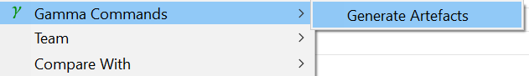

Click on the *generated file* and select the PlantUML view in Eclipse, to visualize the generated scenario contract statechart.

The scenario contract statechart has three special states. The *ColdViolation* state collects inconclusive traces, while the *HotViolation* collect invalid ones. The *AcceptingState* collects traces that conform to the interactions described in the scenarios, with respect to the annotations. Every other state represents a point in the scenario, up until which, every interaction of the concrete execution matches the expected interaction. Interactions are represented by complex choice transitions. The figure below shows a model element derived from an interaction sent by the component.

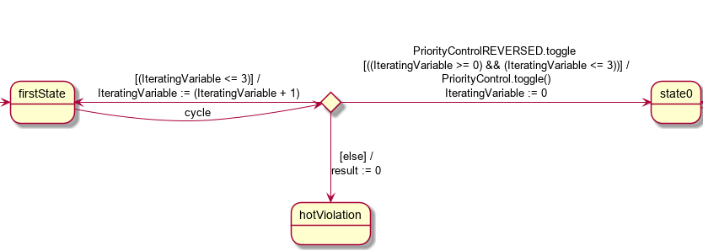

The transition leading to the choice state fires in every synchronous execution turn. At this state, it is examined whether the expected interactions were sent by the component. If they were, and the component waited enough execution turns according to the *AllowedWaiting* annotation, the transition leading to the next state fires. If this transition is unable to fire, and the component did not wait more execution turns, then the limit set by the *AllowedWaiting* annotation, the transition leading to the previous state fires. If neither of these transitions could fire, the transition leading to the appropriate violation state fires. In the case of a *Strict* annotation, the transition leading to the next state and to the previous state is extended by a guard, which evaluates to true, if no interactions in addition to the specified ones were present.

From these scenario contract statecharts (formalized scenarios), it is possible to generate abstract tests that can be used to verify the component. Generally, this generation needs to be defined in a *.ggen* file. Within this file, you can set the scenario contract statechart, an output folder relative to the project, and an orchestrating constraint, if the model has timing (as it does in this example). The transformation can be executed by right-clicking the *.ggen* file, and selecting the *Gamma Commands > Generate Artefacts* menu item.



You can find the *TestGeneration.ggen* file in the folder of the scenarios in addition to the generated statechart. After invoking the artifact generation, a new folder should appear with the name set in the TestGeneration.ggen file, containing the generated abstract tests. Every test describes an execution trace conforming to the scenario, thus, any of the generated tests passes, the behavior of the component is accepted.

## Test Generation from Adaptive Contracts

Gamma also supports the specification of activation and deactivation of scenario contracts during the execution of the system. To this end, the Gamma Adaptive Contract Language (GACL) can be used. The language is an extension of the GSL language, allowing the specifications of adaptive contracts, that is, the activation and deactivation of static scenarios upon specific events. GACL builds on GSL and supports powerful constructs, such as composite states, parallel regions, history states, variables, and complex transitions, such as choice, fork and join.

As a key feature, GACL supports linking a set of GSCL scenarios to states, therefore scenario management can also benefit from the high-level features of statecharts. During execution, the current state configuration indicates the active scenario set. When processing incoming events, the GACL statechart has priority over the active scenarios. When a state configuration is left, the scenarios linked to the left states get deactivated, and the ones linked to the newly entered states get activated. As scenarios do not have history, the examination of behavior always starts at the *beginning* of the scenario.

## Test Generation Task

You can find such a statechart, named *AdaptiveContractCrossroad.gcd* in the *specification* subfolder of the model folder in your project.

The figure below shows the *AdaptiveContractCrossroad.gcd* statechart, which describes, the behavior of the system. After starting the system, it begins its *Initial* phase. Two seconds later, the system starts its normal behavior. In case of a *police.police* event, the behavior changes to *Blinking*, however in case of another *police.police* event and if a second has passed, the behavior changes back to *Normal*.

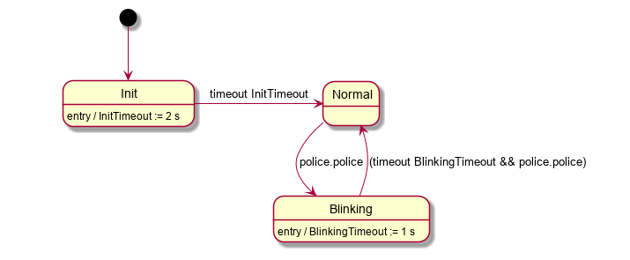

Furthermore, there is a *Contracts.gsc* file describing three scenarios specifying the behavior of the *Crossroads* system.

Your task is to complete the scenarios based on the comments and the expected behavior of the system.

From the *Contracts.gsc* file, you can generate Gamma scenario contract statecharts the same way as before. After refreshing the project, the errors in the adaptive statechart should disappear.

Moreover, you can find afile, called *Crossroad.ggen* in the same folder, which describes a configuration for the adaptive test generation based on the specifications. It contains the following specification:

*adaptive-test {*

*analysis {*

*component : AdaptiveContractStatechart*

*language : Theta*

*state-coverage*

*constraint : {*

*minimum-orchestrating-period : 2000 ms*

*maximum-orchestrating-period : 2000 ms*

*}*

*}*

*language : java*

*}*

By right-clicking on the *Crossroad.ggen* file and selecting the *Gamma Commands > Generate Artefacts*, you can generate the abstract tests, which can be found, in the trace folder of the project.



These abstract tests contain the steps of when a scenario should be activated, and the steps generated from the scenario.

From these abstract tests, you can generate concrete tests.

Do the generated tests pass? If not, what is the problem? Can you redesign the original statechart models of the system to make the tests pass?